**KVR GOVERNMENT DEGREE COLLEGE FOR WOMEN (A)**



**Accredited ‘A’ Grade by NAAC**

**(Affiliated to Rayalaseema University)**

**Near Railway Station, Kurnool.**

**------------------------------------------------------------------------------------------------------------------------------------------**

Name of the Employee: G. Deva Kumari 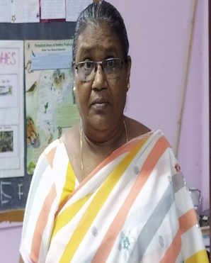

Qualification: SSc

Designation: Attender

Employee ID: 09423

Department working: Zoology

Date of Birth: 02-06-1971

Date of Joining: 19-09-2008

Experience: 14 years

Phone no: 7893165877